摘要：
针对问题三，我们在分组检验的基础上，创造了浓缩优化法，以牺牲检测阶段数为代价，增加浓缩样本的阶段，减小总样本规模，以此提高总样本的感染率。以样本总量为30000人，感染率为0.002的情况为例，浓缩优化法模型的检测总次数的数学期望为1375.4，仅用题一中模型的检测总数的数学期望为2624.3，对比之下可发现浓缩优化法的显著的提升了效率。此外，对于患病率的样本，此法还能多次使用，优化效果显著。

问题分析：
问题三要求我们提出一种新的群组检测方案，此方案不需要受分组的约束，并需要利用具体的数值案例来说明在该种方法下检测的效率会提高。我们考虑的是先确定分组的必要性，然后通过将阳性的感染者缩小到一个更小的样本范围中，来建立一个更加高效的检测方案。
首先考虑我们的目标，根据题目要求，我们需要制定出更为高效的模型，因此我们的模型就以检测次数为衡量准则，通过降低样本和感染率不变情况下的检测次数，来实现高效化。
其次我们考虑过程，我们的想法是利用浓缩的思想，将有限的感染者阳性样本浓缩到相较于总的样本范围而言更加小的样本范围中，提升样本范围内的感染率，然后将浓缩后的模型代入群组检测模型，计算出一个总的检测次数。
最后我们分析结果，建立出将有限个阳性样本浓缩到更小范围样本的模型，并带入多组数据值，计算出多组数据下的总检测次数，与题一模型的检测次数对比，衡量效率。
Abstract
In response to question three, we created a concentrated optimization method on the basis of group testing. At the expense of the number of detection stages, we increased the stages of concentrated samples and reduced the total sample size to increase the infection rate of the total samples. Taking the case where the total number of samples is 30,000 people and the infection rate is 0.002 as an example, the mathematical expectation of the total number of detections of the concentrated optimization model is 1375.4, and the mathematical expectation of the total number of detections of the model in question one is 2624.3. It was found that the concentrated optimization method significantly improved the efficiency. In addition, for prevalence samples, this method can be used multiple times, and the optimization effect is significant.

problem analysis:
Question 3 requires us to propose a new group detection scheme, which does not need to be constrained by grouping, and needs to use specific numerical cases to illustrate the efficiency of detection under this method. What we consider is to determine the necessity of grouping first, and then to establish a more efficient detection program by narrowing the positive infected persons to a smaller sample range.
First consider our goal. According to the requirements of the topic, we need to develop a more efficient model. Therefore, our model uses the number of detections as a criterion to achieve high efficiency by reducing the number of detections under the condition that the sample and the infection rate remain unchanged. .
Secondly, we consider the process. Our idea is to use the idea of ​​concentration to condense the limited positive samples of infected persons into a smaller sample range than the total sample range, increase the infection rate within the sample range, and then condense The latter model is substituted into the group detection model to calculate a total number of detections.
Finally, we analyzed the results and established a model that condensed a limited number of positive samples into a smaller range of samples, and brought in multiple sets of data values, calculated the total number of detections under multiple sets of data, and compared it with the number of detections in the first model. effectiveness.

Step1关于考虑因素
- 分组数（）：
由参考文献[]，我们可知，若不分组进行样本检测，则每个人的检验次数都为1；若要分组进行检测，那么分组后人均检验次数小于1，则认为分组检测的效果要好于不分组检测，否则不分组的检测效果更好。因此，我们通过计算来验证分组是否能够有效提高效率。
在分组的情况下，假设每组人数有,变量表示每个人的检验次数，表示检验结果为阳性概率，表示检验结果为阴性的概率。其中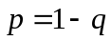。
若一组混合样本的检测结果为阴性，则可求出该组检测出阴性的概率为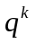，因为不需要再进行单独检测，所以组中每个人的平均检验次数为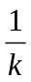,；
Step1 What we need to consider
The number of groups ():
From the reference [], we know that if the samples are not grouped for testing, the number of inspections for each person is 1. If you want to group for testing, then the average number of inspections per person after grouping is less than 1, then the effect of grouping testing is considered to be better than that of no testing. Group detection, otherwise the detection effect without grouping is better. Therefore, we use calculations to verify whether grouping can effectively improve efficiency.
In the case of grouping, suppose there is for the number of people in each group, variable represents the number of tests for each person, represents the probability of a positive test result, and represents the probability of a negative test result. Where .
If the test result of a group of mixed samples is negative, the probability of the group being tested negative can be calculated as . Because there is no need to perform separate tests, the average number of tests for each person in the group is ,
若一组混合样本检验结果为阳性，由于一组检验结果只有阴性和阳性两种可能，阴性的检测结果概率是，因此该组检测出阳性的概率为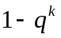，组中的每个人还需要进行单独检测，因此每个人平均检验次数为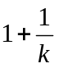次。

通过数学知识列出检验次数的分布律
If the test result of a group of mixed samples is positive, because there are only two possible test results for a group of negative and positive, the probability of a negative test result is , so the probability of a positive test for this group is . Everyone in the group needs to do Individual testing, so the average number of tests for each person is .
List the distribution law of the number of tests through mathematical knowledge
Number of test
probability

求出人均的检验次数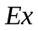
Find the number of inspections per capita
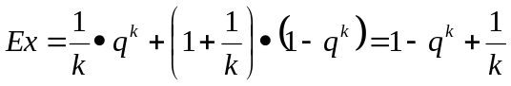，
我们将人均检验次数的多少来确定分组的问题转化为通过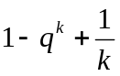与1的关系来确定分组的必要性问题。经过求导等一系列的数学计算后，求出当小于0.31，分组会变得高效，而我们由香港的感染率推出的香港的患病率约为0.001，远小于计算值0.31.
因此通过计算我们可以知道分组在我们模型条件的背景下是对于检测方法而言有益的，因此我们可以得出结论，分组是需要的。
We transformed the problem of determining the group by the number of inspections per capita into the problem of determining the necessity of grouping through the relationship between and 1. After a series of mathematical calculations such as derivation, it is found that when is less than 0.31, the grouping will become efficient, and our prevalence rate in Hong Kong derived from Hong Kong's infection rate is about 0.001, which is much smaller than the calculated value of 0.31.
Therefore, through calculation, we can know that grouping is beneficial to the detection method in the context of our model conditions, so we can conclude that grouping is needed.

Step2模型的建立
通过step1中严谨的计算过程可以知道分组是必要的，因此我们建立了浓缩优化群组检测模型。浓缩模型的核心思想就是利用分组检测将检测结果为阳性的人筛选出来，剔除结果为阴性的分组人群，缩小有限个阳性样本所在的总样本数量，提高剩余样本中的感染率，再利用问题一中的群组检测模型来计算。我们考虑该模型最大检测次数的情况，因为当在最大检测次数可能性下的具体数值的检测效率高于问题一的群组检测模型效率，则可以知道该模型的效率会高于问题一群组检测模型。具体步骤如下：
Step2 model establishment
Through the rigorous calculation process in step 1, we can know that grouping is necessary, so we established a concentrated and optimized group detection model. The core idea of the condensed model is to use group detection to screen out those with positive test results, eliminate grouped people with negative results, reduce the total number of samples with a limited number of positive samples, increase the infection rate in the remaining samples, and reuse problem one In the group detection model. We consider the maximum number of detections of the model, because when the detection efficiency of the specific value under the possibility of the maximum number of detections is higher than the efficiency of the group detection model of question 1, then it can be known that the efficiency of the model will be higher than the group of question 1. Check the model. Specific steps are as follows:
Step1确定分组的组数
Step1 Determine the number of groups
由于样本中感染人数不同，会导致感染人数被随机分配在不同小组中的概率不同，我们考虑检测次数最多的情况，也就是每位感染者各自在一个分组，即每个组内最多仅有一个感染者，感染人数为：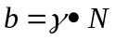
其中为感染人数，为检测次数最多情况下存在感染者的组数，也就是分组数量的下限，为感染率，为样本总人数.我们将满足条件的分组个数都进行遍历，从所有的分组中，选择出所需要总检测次数最少的一种情况来进行分组。
Since the number of infected persons in the sample is different, the probability of the infected persons being randomly assigned to different groups will be different. We consider the case of the largest number of tests, that is, each infected person is in a group, that is, there is only one in each group. The number of infected persons is:
Among them, is the number of infected persons, ？？？？？？ is the number of groups with infected persons under the highest number of tests, that is, the lower limit of the number of groups, is the infection rate, and is the total number of samples. We will traverse the number of groups that meet the conditions. From all the groups, select the one that requires the least total number of detections to group.
Step2 计算过程
用step1中的遍历方法求出在检测次数最多情况下的分组数，其中含有感染者的组数为，然后将各个组的混合样本进行检测分析，计算呈阴性混合样本的患者数量为
Step2 calculation process
Use the traversal method in step 1 to find the number of groups under the highest number of detections. The number of groups containing infected persons is . Then the mixed samples of each group are tested and analyzed, and the number of patients with negative mixed samples is calculated as
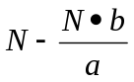
其中为检测次数最多情况下存在感染者的组数，也就是感染者数量，为样本总数，为分组数量。
因此我们易知剩余的待检测人数为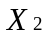，
Among them, is the number of groups where there are infected persons under the highest number of tests, that is, the number of infected persons, is the total number of samples, and is the number of groups.
Therefore, we can easily know that the remaining number of people to be tested is,
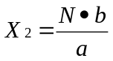
之后我们利用问题一的群组检测模型来计算出剩余部分的总的检测数量，将计算的结果加上浓缩中的的检测数量，也就是分组的数量，可以计算出浓缩优化模型下的总的检测数：
Then we use the group detection model of question 1 to calculate the total number of detections in the remaining part, and add the calculated result to the number of detections in the enrichment, which is the number of groups, to calculate the total number of the enrichment optimization model Number of inspections:
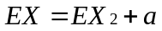
其中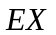为总的检测次数，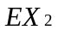为代入模型一后算出来的剩余人数的总的检测次数。
Among them, is the total number of detections, is the total number of detections of the remaining people calculated after substituting into the model 1.

Step3结果对比
我们将具体的数值分别代入问题一中的群组检测模型和问题三中的浓缩优化模型。再进行了多种不同情况效率的比对，证明了该浓缩优化模型的效率高于群组检测模型，代入数值和通过枚举遍历法计算出来的分组数量的具体数值如下：
Step3 result comparison
We substitute the specific values into the group detection model in problem one and the condensed optimization model in problem three. A comparison of the efficiency of a variety of different situations proved that the efficiency of the enrichment optimization model is higher than that of the group detection model. The specific values of the substituting values and the number of groups calculated by the enumeration traversal method are as follows:
Numerical Number
1 | 400 | 0.001 | 40000
2 | 200 | 0.001 | 20000
3 | 100 | 0.001 | 10000
4 | 500 | 0.002 | 30000
5 | 625 | 0.002 | 40000

利用上述数值，我们分别代入优化后的浓缩模型和问题一中的群组检测基本模型进行合理的计算，得出如下的各自模型的期望，通过总的检测次数的含义，我们知道，当数值越大，所需要的检测次数会越多，相对应的模型效率也越低。我们对比两者的效率，通过图表来形象地反应两者的关系：
Using the above values, we respectively substitute the optimized concentration model and the basic group detection model in question 1 to perform reasonable calculations, and obtain the following expectations of the respective models. A. The larger the value, the more detection times will be required , The corresponding model efficiency is also lower. We compare the efficiency of the two and visually reflect the relationship between the two through graphs:

Numerical Number | Concentrate optimization results | Group detection model
1 | 1160.252 | 2504.995
2 | 586.6901 | 1252.5
3 | 290.0631 | 626.25
4 | 1375.4 | 2624.283
5 | 1831.566 | 3499.044
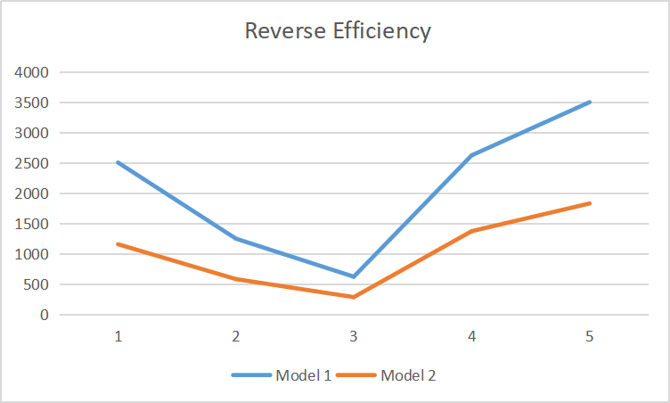

我们可以通过图表发现，问题三中的浓缩优化模型在取最大检测次数的情况下计算出来的远小于问题一中群组检测基本模型的，因此我们可以知道浓缩优化模型的效率远高于群组检测模型的效率。

We can find from the chart that the concentrated optimization model in question 3 takes the maximum number of detections and the calculated is much smaller than the of the basic group detection model in question 1, so we can know that the efficiency of the concentrated optimization model is much higher than that of the group Check the efficiency of the model.

